LINDEN ROBOTICS
FRC-3568 ROBOEAGLES
FTC-7031 BATTLE BLAZERS
FLL-10101 LEGO EAGLES

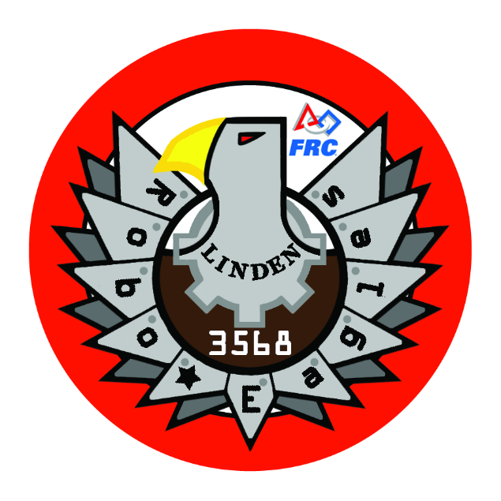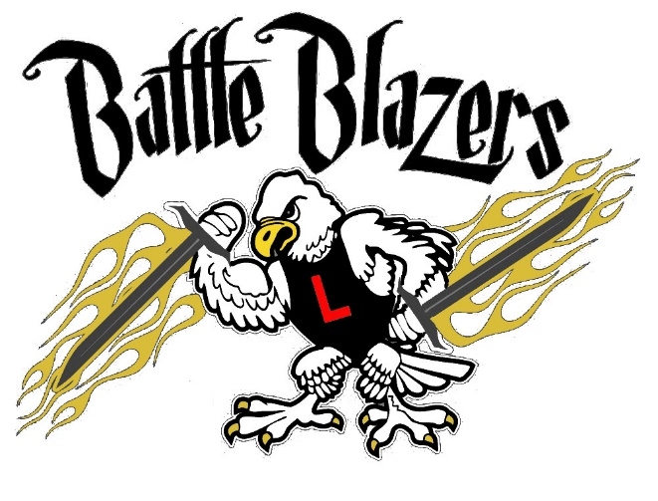

BUSINESS PLAN
Table of contents
Contents
Team Summary 3
Mission Statement 3
Team Formation 3
Location 3
Current leaders 3
Current Team members 3
Our Team 3
Our sponsors 4
What we do 4
Ftc Game season 4
Off-season 4
Long term goals 4
What is First? 5
Team information 6
Our Brief History 6
Award history 6
Parent Support 6
Fundraising 6
Social Media 6
Website 6
Facebook 6
Email 6
Youtube 7
Community Outreach 7
Membership Fees 7
Budget 7

Team Summary

Mission Statement

Linden Robotics strives to bolster student curiosity and creativity, teach teamwork, and build self-confidence while inspiring them to pursue careers within the S.T.E.M. fields.

Team Formation

2011 – FRC-3568 Linden RoboEagles

2013 – FTC-7031 Linden Battle Blazers

2017 – FLL-10101 Linden Lego Eagles

Location

Linden Community Schools, MI

Current Leaders
John Bonasse
Angela White
Hugh (Bill) Miller
Shannon Smith

Current Team Members

Noah Deromedi
William (Billy) Kenyon
Luke Miller
Zachary Shelton
Laurel White
Gabrielle (Gabby) White
Liam Boillat
Dominic Bonasse
Jon Cross
Theodore (Ted) Farley
Elizabeth Glover
Mary-Carole Glover
Ashton Howard
Sean Miller
Jacob Monaghan

Our Team
Our team currently has fifteen team members, four adult mentors and many involved parents.
The program is currently 27% female, 73% male, and 100% committed to our program and its sponsors.
Our Sponsors
Our team is sponsored through the Fiat Chrysler Foundation (FCA foundation). Without their financial support, we would not be able to provide the students with the opportunity to be a part of the FIRST program.
Also, the Linden Community School District provides us with a means to operate financially, and to meet in, and use, the school facilities.
The Linden Robotics program would like to thank our sponsors for their generosity and we strive to earn their efforts by providing the students with the best opportunities we are able to.

What We Do

Game Season –
Each team attends an event kickoff to start their season where they are given a game to play. They develop a game strategy which is then used to build a robot to perform those tasks that are identified.
The students learn how to use the engineering process to plan, prototype and build their robot. Something unique to the FTC program, they document their process in an Engineering Notebook that they use at their competitions to win various awards.
The teams usually compete in two qualifier events each season, in an attempt to qualify for the state championships. Based on their performance they can then continue on to regional and world competitions.

Off-Season –

During the off season, the team focuses on training activities, community outreach, and team building activities.

Long term goals
FLL-10101 Lego eagles – We are currently in the process of forming a FLL robotics team to help raise the communities interest in robotics and other S.T.E.M. careers. The FLL program will act as a feeder team for the FTC, and in turn the FRC teams.
Jr. FLL – Hyatt jr. Lego Eagles & Linden El. Jr. Lego Eagles – We hope to be able to start Jr. FLL teams in each of the two K-3rd grade elementary schools within the next three years. In addition to helping grow the existing teams, we’ve seen a huge interest in our community for this age range of students.

What is First?
(Taken from firstinspires.org)
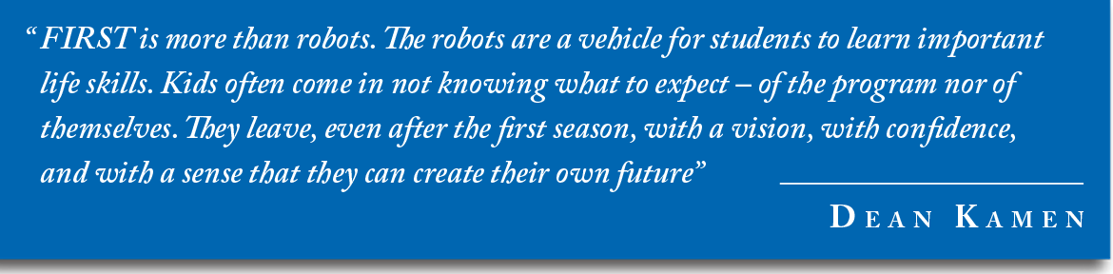
The mission of FIRST is to inspire young people to be science and technology leaders, by engaging them in exciting Mentor-based programs that build science, engineering, and technology skills, that inspire innovation, and that foster well-rounded life capabilities including self-confidence, communication, and leadership.
Engage kids in kindergarten through high school in exciting, Mentor-based, research and robotics programs that help them become science and technology leaders, as well as well-rounded contributors to society.
Dean Kamen is a prolific inventor, entrepreneur, and tireless advocate for science and technology. His passion and determination to help young people discover the excitement and rewards of science and technology are the cornerstones of FIRST. For over 25 years, Kamen has resolutely led the growth of FIRST to where it is now universally recognized as the leading, not-for-profit STEM engagement program for kids worldwide.
FIRST (For Inspiration and Recognition of Science and Technology) was founded in 1989 to inspire young people's interest and participation in science and technology. Based in Manchester, NH, the 501(c)(3) not-for-profit public charity designs accessible, innovative programs that motivate young people to pursue education and career opportunities in science, technology, engineering, and math, while building self-confidence, knowledge, and life skills.
Two of FIRST’s Values are Gracious Professionalism® and Coopertition®.
Dr. Woodie Flowers, FIRST Distinguished Advisor and Pappalardo Professor Emeritus of Mechanical Engineering, Massachusetts Institute of Technology, coined the term "Gracious Professionalism®."
Gracious Professionalism is part of the ethos of FIRST. It's a way of doing things that encourages high-quality work, emphasizes the value of others, and respects individuals and the community.
With Gracious Professionalism, fierce competition and mutual gain are not separate notions. Gracious professionals learn and compete like crazy, but treat one another with respect and kindness in the process. They avoid treating anyone like losers. No chest thumping tough talk, but no sticky-sweet platitudes either. Knowledge, competition, and empathy are comfortably blended.
In the long run, Gracious Professionalism is part of pursuing a meaningful life. One can add to society and enjoy the satisfaction of knowing one has acted with integrity and sensitivity.
Coopertition® produces innovation. At FIRST, Coopertition is displaying unqualified kindness and respect in the face of fierce competition. Coopertition is founded on the concept and a philosophy that teams can and should help and cooperate with each other even as they compete.
Coopertition involves learning from teammates. It is teaching teammates. It is learning from Mentors. And it is managing and being managed. Coopertition means competing always, but assisting and enabling others when you can.

Team Information

Our Brief History
We are in the process of gathering the information for the program through its six year history.

Award history
We are in the process of gathering the information for the program through its six year history.

Parent Support
Our parents are awesome. They generously support our team in a variety of ways. Many have solicited sponsorships from their employers, others have donated their time as mentors, and some have helped defray the various program costs. We have parents that volunteer their expertise in fundraising, help us write grant proposals, and solicit other corporate donations.

Fundraising
We are always exploring new fundraising opportunities. In the past we have sold sports raffle tickets, pizza kits and LED light bulbs. We also hosted a summer Lego Engineering and Science Week at our local middle school. We offered the program through our districts Community Education program, and used the proceeds to fund our robotics program.

Social Media

Website –
www.lindenrobotics.weebly.com

Facebook –
https://www.facebook.com/RoboEagles
Email –
lindenrobotics@gmail.com lindenroboeagles@gmail.com
battleblazers@gmail.com lindenlegoeagles@gmail.com

YouTube –
www.youtube.com/user/LindenRobotics

Community Outreach
We attend the local elementary school science fairs to help promote our robotics program, FIRST Robotics, and S.T.E.M. activities. We usually take the FTC and FRC robots that were built from the previous season, and we allow folks to drive them.
We have also used other tools such as Finch robots and Ozobots to show different technologies that are available to generate interest in technology.

Membership Fees
We try to keep the program affordable to allow anyone that is interested to participate. The current FTC registration fee is $75, which includes event registration costs, team supplies and a team shirt. We meet year round, using the off-season to train and team build. FRC is a little bit more at $125 due to the increased costs and additional shirt and sweatshirt. The FLL cost has not been finalized as of yet.
Additional costs for food and travel, as well as team spirit items are charged directly to the team members as required.

Budget
The FRC team registration fee is currently $5,000. Game elements, material and other supplies, tools, and administrative costs total approximately $2,500 each season.
The FTC program team registration fee is currently $275, and $100 per qualifier event. Game elements, material and other supplies, tools, and administrative costs total approximately $1,000 each season.
The FCA foundation generously provides $5,000 and $475 respectively to the program which covers the initial registration costs. All other funds must be raised by the team through team member registration and fundraising.
We have also applied for state and other grants when available. The Michigan Department of Education has generously awarded us grant monies in the past to help support our program.
The FLL program currently has no sponsorship and will be funded through the MDE grant and other team funds.
In all, we have a total minimum required budget of around $11,000 to run the three programs.

